Pg. 155 - 161, Java Programming *A comprehensive Introduction*

**Section 1: Define / Answer**

Data Structure-

Holds data to use effectively. Organizes the data in a specific fashion or in a unique way to use it more efficiently. Helps to manage data,

Has different type of data structure e.g Array, Arraylist, Linked list, hashes, hash seats, heaps, binary, binary tree

Array:

Collection of primitive data type

In java arrays have to hold all the same type of primitive data type.

Static Fixed / data structure. The size of the array has to be declared when it is created.

Primitive Data Type Variables:

Booleans, Int, Bytes, Doubles, Floats, Shorts, Long, Char = 1 characters – single letters A, B, C etc, Symbols, Space, “”, 0-9

One-Dimensional Arrays:

Single variable representation of a set of primitive data types. (All data types must be the same.)

Type [] array-name = **new** type[size]

What is the significance of **new**?

New helps to allocate the memory that we needed.

Array Element:

The value or the actual individual data.

Array *Index:*

Location of individual primitive data type in a particular array.

How is 0 used?

0 is the first element of an array.

Array Initializers?

Array initialize each element that we put in an array and initialization starts with the index 0 to less than one of the total elements.

|  |  |  |  |  |
| --- | --- | --- | --- | --- |
| 1st Position  For Data | 2nd Position  For Data | 3rd Position  For Data | 4th Position  For Data | 5th Position  For Data |
| 0 | 1 | 2 | 3 | 4 |

Iterator-

Allows for the search of each element in an array. The most basic example is for loop.

**Programming Assignment**

Pg. 201, Java Programming *A comprehensive Introduction*

Task 1- Page 201 # 1:

Show two ways to declare a one-dimensional array of 12 doubles.

{1.0, 2.0, 3.0, 4.0, 5.0, 6.0,7.0, 8.0, 9.0, 10.0, 11.0, 12.0};

For the first example print the 7.0 and 10.0 in a println.

Example - Your println should match

7.0

10.0

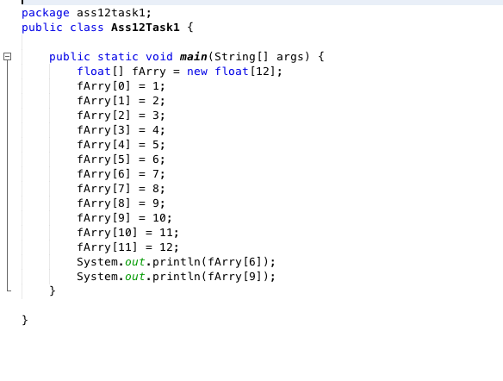

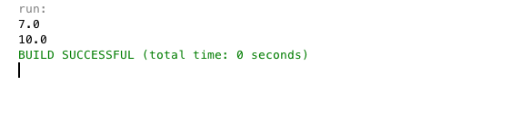

For the first example print the 2.0 and 12.0 in a println.

Example - Your println should match

2.0

12.0

Attach a 2 different snipping photos. The Snipping photos should include the programmer source code and the outputs.

Pg. 201, Java Programming *A comprehensive Introduction*

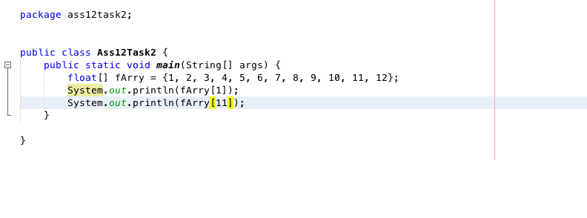

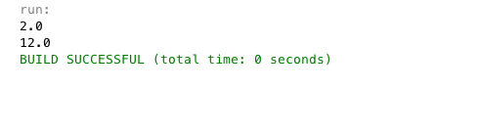

Task 2- Page 201 #3:

Write a program that uses an array to find the Average of 10 double values.

Use Math.random() in combination with a **for** loop to fill the array with 10 random values.

Then use a different **for** loop to iterate through the array when summing the total for all 10 double values.

Attach Snipping photos of source code and output.

